**SIR SYED UNIVERSITY OF ENGINEERING AND TECHNOLOGY**

**Project Report File**



**Information Technology Department**

**Project Name: Medicare**

**Submitted To: Mariam Baig**

**GROUP MEMBERS**

|  |  |
| --- | --- |
| **Ahmed Hussain** | **2023F-BIT-119** |
| **Anas Wahab** | **2023F-BIT-087** |

***Course Name: Computer Networks Lab (CS-317L)***

***Semester: 4th Batch: 2023F***

**Acknowledgment**

In the pursuit of knowledge and the completion of my academic endeavours, I begin by expressing my deepest gratitude to Allah, the Most Merciful and Compassionate, for bestowing upon me the strength, wisdom, and guidance throughout this journey. My name is Ahmed Hussain, and I am enrolled in the BSIT department at SSUET.

I would like to extend my sincere appreciation to my mentor, Miss Mariam Baig, whose unwavering support and guidance have been instrumental in shaping my academic and personal growth. Her dedication to fostering a learning environment and commitment to excellence have been a constant source of inspiration.

Moreover, this achievement wouldn't have been possible without the collective support and encouragement from all those who have played a role in my academic pursuits. To my professors, whose knowledge and expertise have been invaluable, and to my fellow students, who have shared in the challenges and triumphs – thank you.

I extend my heartfelt thanks to my friends and family for their unyielding support, understanding, and encouragement. Their belief in my abilities has been a driving force behind my success.

In addition, I express my gratitude to the institution, SSUET, for providing a conducive learning environment and resources that have enriched my educational experience.

This acknowledgment is a reflection of the collaborative efforts that have shaped my academic journey. Each individual and entity mentioned has contributed in their unique way, and I am profoundly grateful for the collective impact that has propelled me towards this accomplishment.

**Table Of Contents**

* Acknowledgment
* Table Of Contents
* Introduction
* Abstract
* Project
* Visuals
* Working
* Layout Of Network
* DNS Server
* Results
* Conclusion

Page No #02

Page No#03

Page No #04

Page No #05

Page No #06

Page No # 08

Page No #10

Page No #10

Page No #11 & 12

**PAGE NO.**

**CONTENTS**

**Medi-Care Network System**

**1. Introduction:**

**a. Where your network topology is aimed to be used? Basic domain knowledge of the area?**

This network topology is designed for a **multi-floor hospital environment**, where seamless communication, resource access, and security are critical. The setup aims to manage department-specific data, inter-departmental communication, and wireless connectivity efficiently across three floors.

**b. What aspects are you considering?**

* Department-wise VLAN segmentation
* Inter-VLAN communication via routers
* DHCP for automatic IP distribution
* Wireless connectivity using Access Points
* Secure inter-floor routing via OSPF
* ~~Restricted access between sensitive departments (e.g., Finance) ( I might consider it~~

**c. Things I did in the network**

* Created VLANs for each department: Check-In, Security, Baggage, ATC, and Administration.
* Assigned devices to their respective VLANs using access ports on switches.
* Configured trunk links between switches and the central router.
* Implemented inter-VLAN routing using sub-interfaces on the router.
* Set up a centralized DHCP server to dynamically assign IP addresses across all VLANs using helper addresses.
* Used OSPF to allow routers to share routing information dynamically.
* Connected wireless access points to support laptops and smartphones in each department.
* Connected a DNS server to the main terminal so every PC could access the website

**2. Abstract:**

**Medicare HealthCare Project – Cisco Packet Tracer Simulation**

This project showcases the design and simulation of a hotel management network using **Cisco Packet Tracer**, aimed at building a secure, efficient, and scalable infrastructure to support multiple departments spread across three floors of a hotel.

The hotel is divided as follows:

* **1st Floor**: Logistics, Store, and Reception
* **2nd Floor**: HR, Finance, and Sales
* **3rd Floor**: ITDept and Admin

Each department operates within its own **VLAN**, such as VLAN 10 for IT, VLAN 40 for HR, and VLAN 80 for logistics. This segmentation improves network performance and security by isolating traffic between departments.

Devices such as PCs, laptops, printers, tablets, and smartphones are connected via **Cisco 2960 switches** and **wireless access points**. Each floor has its own Wi-Fi access with unique SSIDs and passwords.

The core of the network is formed by **three Cisco 2911 routers** (F1, F2, F3) connected in a **triangular topology** using serial links (e.g., 10.10.10.0/30), providing robust routing between floors and VLANs. Inter-VLAN routing and device communication are efficiently managed through these routers.

This design supports centralized user access, allows for future internet integration, and provides high availability and secure communication across departments. The project effectively demonstrates the application of networking concepts such as VLANs, IP

**3. Project:**

**a. Approach to the problem**

We approached this hospital scenario by dividing each floor into dedicated departments, each placed in different VLANs to ensure isolation and control. Inter-VLAN communication was enabled through sub-interface configuration on routers. DHCP was used for automated IP assignment, and OSPF was selected for routing between routers.

**b. Components**

* Deployed 3 routers (2911) and 3 switches (one per floor)
* Assigned unique VLANs to each department
* Configured DHCP pools for each VLAN
* Enabled inter-VLAN routing using router sub-interfaces
* Implemented OSPF as the dynamic routing protocol
* Deployed Access Points for Wi-Fi access

**c. Design**

The design of each floor is mostly similar to each other. First floor got 3 department in itself. Then Second Floor is also following same process. Third floor is divided into 2 departments.

* **First Floor:** Reception (VLAN 80), Store (VLAN 70), Logistics (VLAN 60)

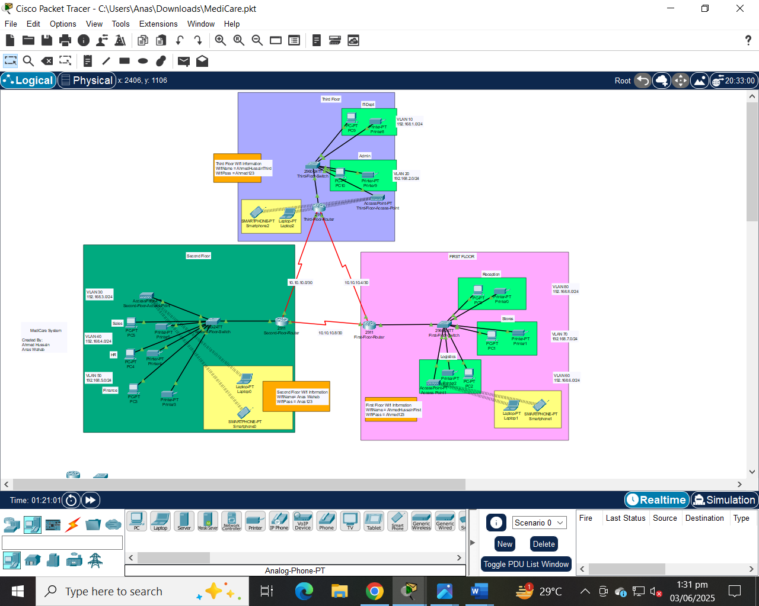

* **Second Floor:** Finance (VLAN 50), HR (VLAN 40), Sales (VLAN 30)



* **Third Floor:** IT (VLAN 10), Admin (VLAN 20)



* Each floor has an access point for wireless connectivity
* Serial DCE connections used between routers with clock rates set

**d. What did/didn't work?**

* **Worked:**
  + DHCP configuration successfully distributed IPs
  + Devices within VLANs communicated correctly
  + OSPF enabled full-floor-to-floor connectivity
  + Inter-VLAN routing worked smoothly
  + Wireless devices successfully connected to Aps
* **Didn't work initially:**
  + Interfaces were in down state until manually activated (no shutdown)
  + Some IP conflicts and ping failures until routing was configured.

**Working:**

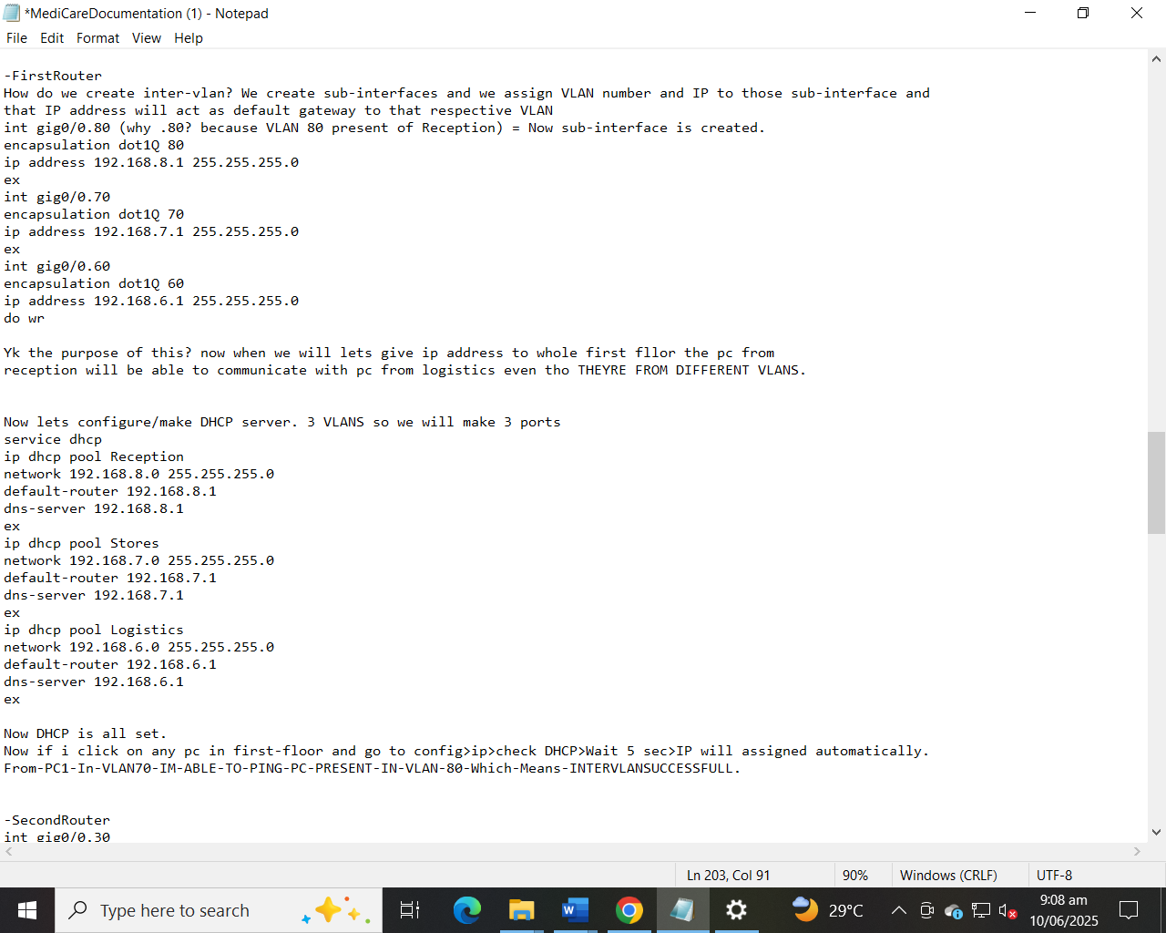

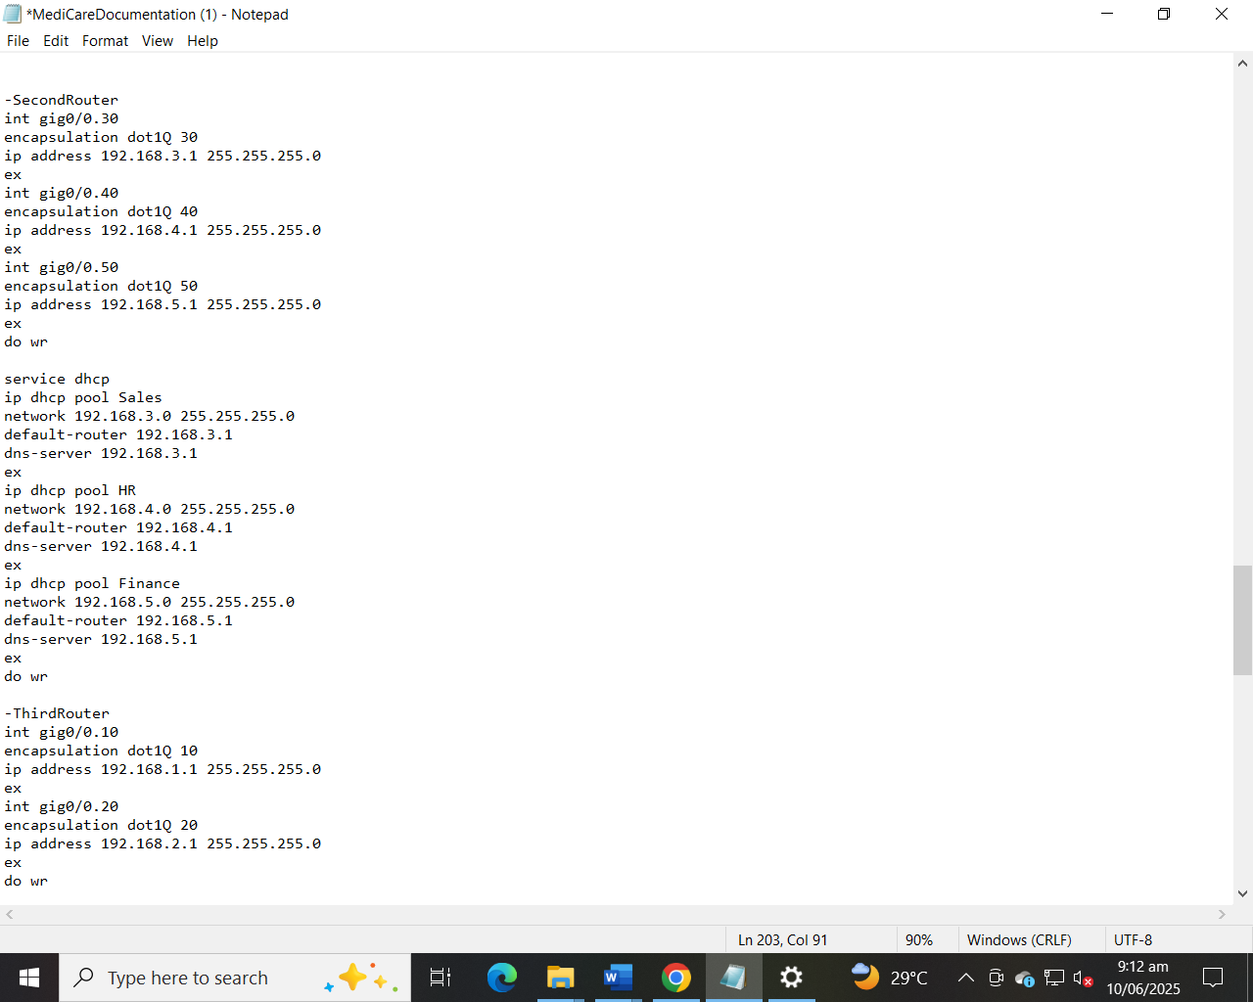

**e. Include graphs, equations, pictures, etc. as appropriate**

* Topology diagram attached (refer to appended image)

**f. Visuals**

**Layout of Medicare System**

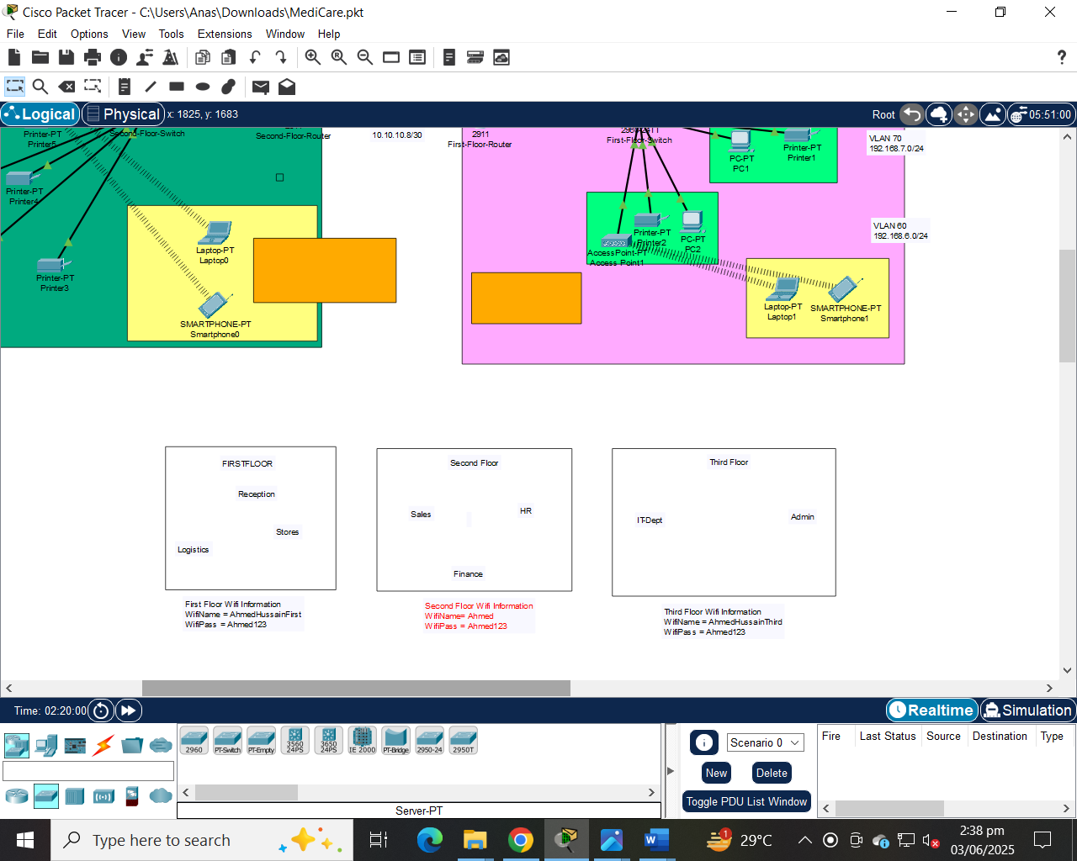

**Types of Devices used in Medicare System**

**WIFI Connection in Laptop**

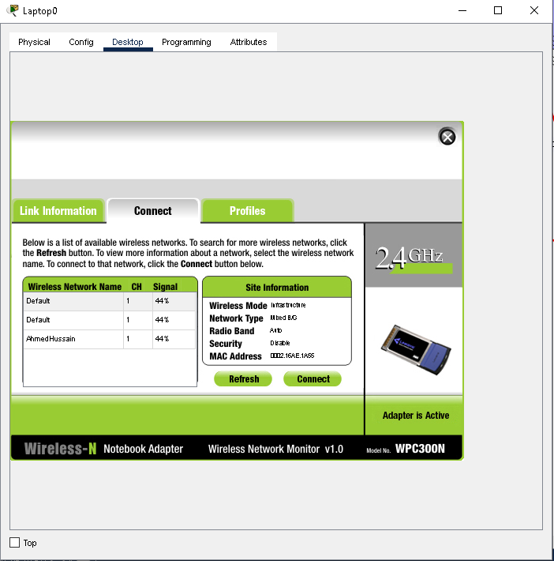

**DNS SERVER:**

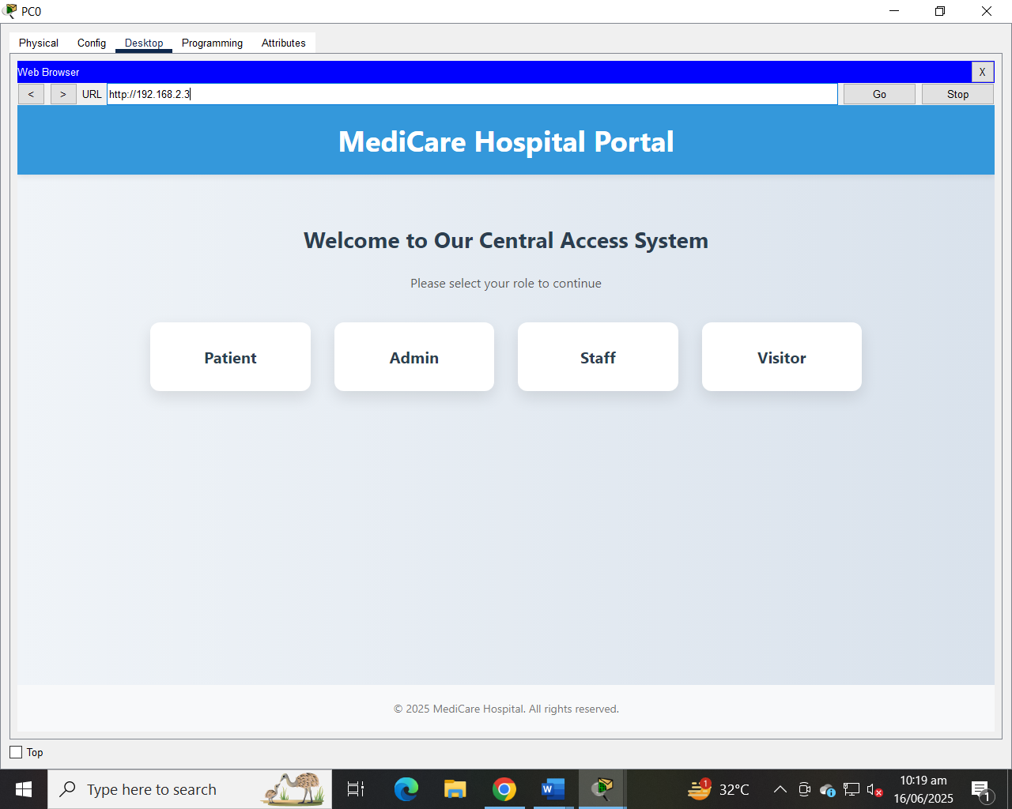

**Server Description:**

This server is configured to host and deliver HTML content as a basic web server within the network. It allows connected devices (such as PCs and phones) to access webpages via a web browser using the HTTP protocol. The server simulates a real-world website by responding to client requests with HTML files stored in its internal storage. It is assigned a static IP address to ensure consistent connectivity and easy configuration across the network. This setup is commonly used for testing web applications, understanding server-client communication, and demonstrating basic website hosting in a controlled networking environment.  
**DNS:**This server is configured as a DNS (Domain Name System) server within the network. It is responsible for translating domain names (such as www.example.com) into IP addresses, allowing client devices to access services using readable names instead of numerical IPs. By handling name resolution requests, the DNS server improves user experience and enables efficient network communication. The server is assigned a static IP address to ensure consistent and reliable DNS resolution for all connected devices in the network.

**Outcome of the Layout of Medicare System**

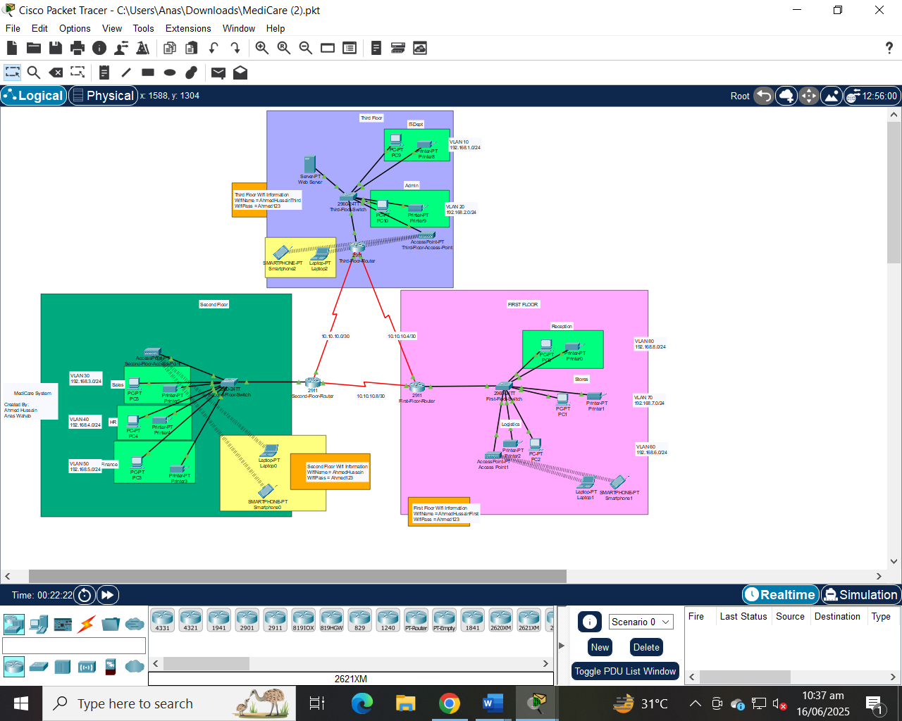

**g. Results**

* **Ping tests:**
  + PC in VLAN 80 successfully pinged PC in VLAN 70 → **Inter-VLAN: PASS**
  + PC in 1st Floor successfully pinged PC in 3rd Floor → **Inter-floor via OSPF: PASS**

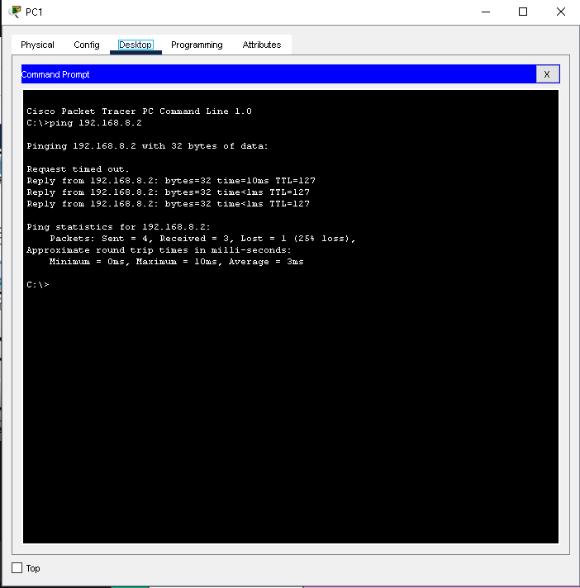

* OSPF Communication: VLAN 10 🡪VLAN 60 (Different Routers):

**4. Conclusion:**

**Skills and Concepts Learned:**

* Complete VLAN configuration and DHCP deployment
* Sub-interface and inter-VLAN routing
* OSPF dynamic routing
* Access Point configuration and wireless client integration

**Things to Improve:**

* Use of Layer 3 switches for simplified routing
* Add ACLs for specific access restrictions (e.g., block Finance from Store)

**Ideas for Future Expansion:**

* Redundancy via HSRP
* Implement security zoning with ACLs/firewalls
* Integrate Syslog and SNMP for monitoring

**4. References:**

**Books:**

* "Computer Networking: A Top-Down Approach" by Kurose and Ross

**Web Resources:**

* Cisco Packet Tracer documentation
* https://www.networklessons.com